Activity with «scientific» article of the days that touches personal choices and lifestyle

Antibodies to misinformation

Educational material for online or in class school workshop

Contributors:Despina,Dimitris,Elli, Sofia, Thanasis ,Krystalia, Maria ,Panagiota,Stelios ,Andreas ,Giorgos (From Cyber Safety youth panel team)

Supervision
Thanasis Hatzilakos (O.U.C),Krystalia Drystela (Cyprus Institute),Sodia Iordanidou(AMI) Panagiota Hatzittofi (Pedagogical Institute)

«Antibodies to Misinformation» C.U.T, US Embassy, MOEC Pedagogical Institute .

flow/instructions
the coordinator (c) gives instructions, sends the team the first massage and he will give ether roles (in small teams) either asks from the class to choose in which role they want to be part of
Each participant could go where it does not suit him at all to see the other side (eg someone who does not like to eat meat to become a voice to the Hunters).

Step 1
The Coordinator gives instructions (c):

- You receive the following article in your account, read it and answer the following questions in groups.

-To split into groups you will choose a role (see below)

Step 2
The Coordinator sends each participant to the group or to the personal screen, whether it is an online activity or to the class control panel.

Message (that the team receives in the cell phone/watches it in a class control panel)
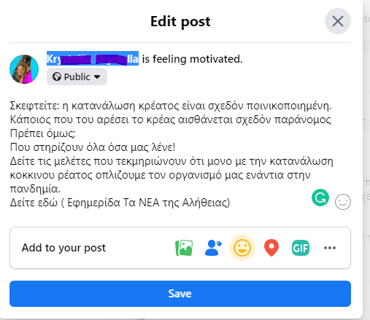
Think about it: eating meat is almost criminalized. someone who likes meat feels almost illegal, but should he?
That support everything they tell us! see the studies that document that only by consuming red meat do we arm our body against the pandemic.
See here (newspaper the news of truth)

Newspaper The NEWS of Truth
Read meat the last weapon for the pandemic, with the timeless magazine Annals of Internal Medicine
The pandemic requires an organism to be fully prepared to resist the virus. Greece's health system cannot stand a third wave of pandemics and mutations are multiplying. So let's see what we can do to protect our body.
First of all exercise, daily and simple. To fit our lives. And of course the diet. We have known since ancient times that what we eat determines our endurance. But what to eat? Should we eat meat or will we become more resilient if we eat plants and roots if we become vegan?
The truth is that lately there is a lot of talk about whether or not we should eat red meat. Is it ultimately a matter of emotional attitude towards mammals that obviously have a life cycle similar to humans? Or is it a matter of dietary attitudes from groups of people who support the vegan lifestyle.
A new study, published in the Annals of Internal Medicine, argues that red meat is an important ally for health support. The study, conducted by a fourteen-member international scientific team, coordinated by Bradley Johnson, an associate professor of public health at the University of Dalhousie in Halifax, concluded that we now need red meat on a daily basis in our diet more than ever.
Red meat is an important source of protein, which is essential for the health of muscles and organs. The protein in meat is "complete", which means that it contains all the amino acids that the body can not create on its own. It is important for the renewal of the cells of the body, the creation of muscles as well as for our health as a whole. According to a study by the American Association of Dietitians in a relevant study, in order to withstand the pandemic, the daily or even 4 times a week consumption of red meat is necessary.
And we need to be aware of the damage done to the body by the lack of red meat according to valid studies and according to the World Health Organization the consumption of red meat helps to fortify the body and ultimately protects us from the risk of COVID 19.

Sources
https://www.meatandgrillstories.com/ofeli-apo-tin-katanalosi-kokkinoy-kreatos/
https://www.ladylike.gr/wellness/skeftesai-na-kopseis-to-kreas-mia-diatrofologos-soy-leei-osa-prepei-na-gnwrizeis-gia-na-to-kaneis-swsta/
http://www.diatrofisimera.gr/ygeia/oxyroste-tin-amyna-tou-organismou-sas-kai-glitoste-apo-tis-iosis/
https://www.kathimerini.gr/world/1045252/salos-gia-meleti-poy-athoonei-to-kokkino-kreas/
Step 3 Divide participants into small groups
Roles (participants are divided into small groups)
- You are a meat lover: How will you react?
- You are a member of an animal protection team
- You are a member of a hunting club
- You are a Buddhist
- …
Step 4
The small groups should discuss for 5-6 minutes and then form a position that they will share with the large group.
Does one of the above roles affect your attitude?
Think about it: eating meat is almost criminalized.
Someone who likes meat feels almost illegal
But should it?
Who support everything they tell us?
Step 5

The large group is discussing.

Notes
An activity that can be adapted to different topics and depending on the interests and age group of the participants. Recommended mainly for children from B high school and above.
Indicative time: from 40 minutes up to 120 minutes
Antibodies to misinformation- Creative Commons
Partners of the project ANTIBODIES to MISINFORMATION
Funding

